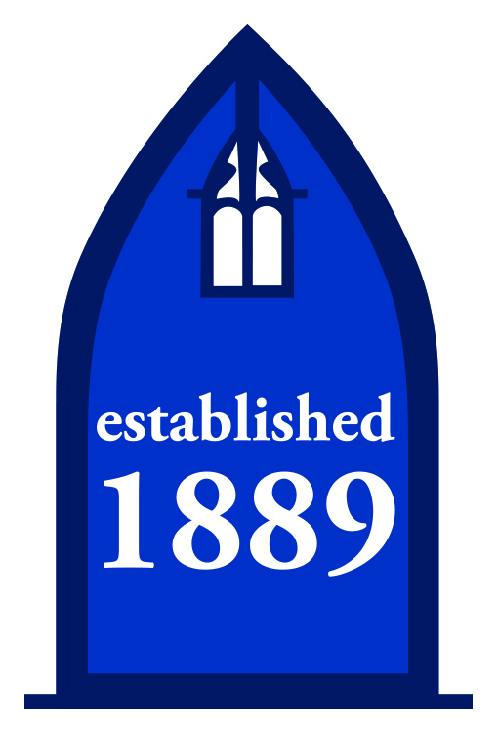
DIRECTIONS ON HOW TO GET TO THE OSTERHOUT FREE LIBRARY
North Branch
28 Oliver Street
Wilkes-Barre, PA 18705
(570) 822-4660
From 81: Take exit 170B to 309N. Take Exit 2 (Central City). Bear right on North Washington Street. At the traffic light, turn right onto George Avenue. Stay on George Avenue to Scott Street. Turn right onto Scott for 1 block and turn right onto Oliver Street. 28 is located on the right in the middle of the second block. For parking, continue past the library to the stop sign and the parking lot is across the street.
From PA Turnpike: Take Bear Creek exit for Rt. 115 South continue to 309N. Take exit 2 (Central City). Bear right on North Washington Street. At the traffic light, turn right onto George Avenue. Stay on George Avenue to Scott Street. Turn right onto Scott for 1 block and turn right onto Oliver Street. 28 is located on the right in the middle of the second block. For parking, continue past the library to the stop sign and the parking lot is across the street.
From Back Mountain: Follow Rt. 309S to exit 2 (Central City). Stay left on the ramp to the stop sign. Turn left onto Wilkes-Barre Blvd which turns into North Washington Street. At the second traffic light turn right onto George Avenue. . Stay on George Avenue to Scott Street. Turn right onto Scott for 1 block and turn right onto Oliver Street. 28 is located on the right in the middle of the second block. For parking, continue past the library to the stop sign and the parking lot is across the street.
From the Central Library: Continue on South Franklin toward Club House Lane. You’ll take the first right onto W Market Street where Citizens Bank should be on the right. After that, you’ll make a right onto Public Square. You will take the first left to stay on Public Square and then take the first right onto E. Market Street where you’ll see Child Development Council on the right. After that, you’ll turn left onto N Pennsylvania Avenue. In about 2 miles, you’ll turn right onto North Washington Street. The next turn you’ll make will be is a left to stay on North Washington Street. You’ll then take a right onto George Avenue and then another right onto Trethaway Street. You’ll make the next right onto Oliver Steet where the library will be on the right.
Parking: There is street parking outside the library and if you continue past the library to the stop sign, you’ll see a parking lot with free parking.

