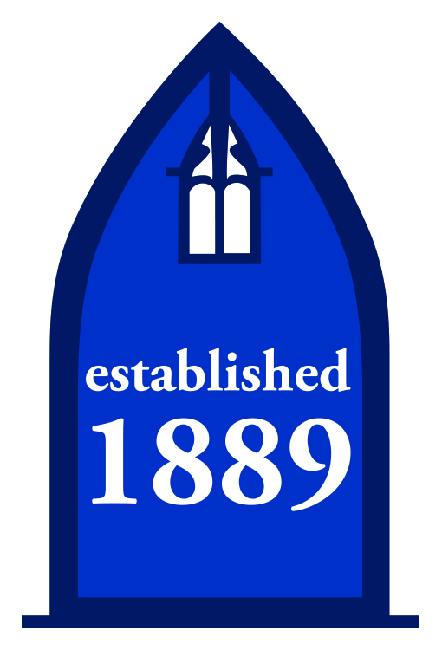
DIRECTIONS ON HOW TO GET TO THE OSTERHOUT FREE LIBRARY
Plains Branch
126 North Main Street
Plains, PA 18705
(570) 824-1862
From the North Branch:
Head Northwest on Oliver Street and take a sharp right on Govier. At the next block turn left onto George Avenue. Follow George Ave for half a mile to where it ends at North Washington and take a right. Continue on North Washington Street to the intersection with East Main (Philly Subs will be on your left). Take a left onto East Main and follow as the road bends to your right and becomes Miller Street. Follow Miller to East Carey and take a left. At the traffic light turn right onto North Main street and follow to the top of the hill. The Plains Township building, where the library is located, will be on your left.

From Route 309, The Cross Valley Expressway (North or South):
Take Exit 3 for Maffett Street/Plains.
From 309
- North bound, use the far right lane from the off ramp to turn a sharp right onto Maffett Street. In less than a mile Maffett will merge with Main. Go past the Turkey Hill (which is on your left) and through the light and follow to the top of the hill. The Plains Township building, where the library is located, will be on your left.
- From 309 South bound use the middle lane off the ramp to turn left at the light onto North River Street. Stay in the right hand lane to veer right onto Maffett Street. In less than a mile Maffett will merge with Main. Go through the light, past the Turkey Hill (which is on your left), and follow to the top of the hill. The Plains Township building, where the library is located, will be on your left.

From the Pittston area:
Follow South Main Street for 2.3 miles and continue as it turns into Lakewood Gardens. In half a mile the road becomes North Main. Continue on N Main for another 1.5 miles. The Plains Township building, where the library is located, will be on your right.

From the Central Branch:
Drive northeast on S Franklin to Market. Turn left on Market and then take the next right onto N River Street. Follow N River St for 1.7 miles and take the right hand lane under the Cross Valley overpass, then veer right onto Maffett Street. In less than a mile Maffett will merge with Main. Go through the light, past the Turkey Hill (which is on your left), and follow to the top of the hill. The Plains Township building, where the library is located, will be on your left.

